|  |  |
| --- | --- |
|  | **GST 113**  **NIGERIA PEOPLES & CULTURE** |
|  | Sarah AJIYA  Cordelia CLAYTON  Tobi JOHNSON  Dinatu B. TANKO  Felix ODOFIN  Cynthia M. SAIDU |

|  |
| --- |
| **[© 2019]** |
|  |



**LESSON 3**

**Major Ethnic groups in Southern Nigeria**

**THE BINI**

It is obvious that the Bini, have played major roles in the history of Nigeria. For instance, the Bini were the first to be visited by the Europeans as early as 1472 A.D. According to Hodgkin the second half of the fifteenth century witnessed the arrival of the first Europeans to Benin. For instance, a Portuguese, Ruy de Sequeira, arrived during Ewuare’s reign in 1472 while Alfonso de Aviero arrived during Ozolua’s reign in 1484.

The Benin Kingdom was also the first in the West Coast of Africa to exchange ambassadors with a major European power, the Portuguese. This was between 1481 and 1504.

**ORIGINS OF BENIN KINGDOM**

**The Egharevba’s Version**

Egharevba (1968) for instance, claims that the Bini people emigrated from Egypt and in the course of their journey southward, settled at Ile-Ife before finally arriving at their present location.

**Igbafe’s Version**

Another tradition has it that the Bini people have been in the area “from the very beginning”. According to Bini mythology, Bini was the youngest child of Osanobua [the High God]. He and his brothers, who included the king of Ife, were sent to live in the world. They were asked by the High God to take whatever they wanted along with them to the world. While others chose wealth, magical skills and material well- being, the youngest on the advice of a bird, chose a snail shell. On arrival, they found that the world was covered by water. Following instruction from the bird, the youngest child over-turned the snail shell, whereupon sand poured out of it and covered a large part of the water to form land. Thus, the 1st ruler of Bini became the owner of the land. Land made him powerful and wealthy as he had to sell portions of it to his elder brothers who then became his subjects.

**Ogiso’s Version**

The first period of pre-colonial Bini history is known as the Ogiso era. This is because their rulers were the Ogisos, which means “kings of the sky”. The first Ogiso was known as Igbodo. He was succeeded by Ere who is credited with forming the guild system and laying solid foundation for the kingdom. Ere was succeeded by Orire, who himself was succeeded by a number of Ogisos among whom were women. The last Ogiso was Owodo.

History tells us that Owodo was the one that clashed with the nobles and eventually became a victim of intrigues of his wives. This led to the banishment of his only son and heir apparent, Ekaladeran. Ekaladeran founded Ughoton, a port-town in Benin. He later moved to Ife through Erua, where he spent the rest of his life. Many years later, because of a serious political crisis in Benin, the nobles sent for him to come back and rule over them. But it was too late. Ekaladeran was very old and decided to send his youngest son Oranmiyan [*Omonoyan = pampered child*] who came and established the Eweka dynasty.

With the end of Ogiso dynasty, Benin went through a period of interregnum during which the elders established a form of republican government headed by Evian who eventually attempted to usurp the throne by nominating his son Ogiamen to succeed him. However, as Evian was not an Ogiso, the Benin people rejected his son Ogiamen. This situation led to a serious political crisis in the Bini Kingdom. During the crisis, two factions emerged: 1) the pro-monarchy and 2) the pro-Ogiamen [also known as Republicans]. This stalemate forced the elders to send a delegation to the Ooni of Ife requesting him to send somebody to Benin to rule over them. The request was granted and Oranmiyan, one of the Ooni’s sons, was sent to rule the Benin people. But on his arrival to Benin Kingdom, Oranmiyan found the Bini people ungovernable. So, he decided to go back to Ife. However, on his way back, history tells us that Oranmiyan had an affair with a Bini woman, the daughter of Enogie of Ego-Erinmwinda. The woman became pregnant and eventually gave birth to a child who later became Eweka I. He is credited with establishing the present Bini dynasty.

A recent version of this episode by some Bini elites maintains that Oranmiyan, who came from Ife to establish the present monarchy, was a Bini prince. According to them, Oranmiyan was the son of Ekaladeran who had earlier been banished from Benin and who subsequently settled at Ile-Ife and eventually became the ruler, Oduduwa. Before Oranmiyan got back to Ife, he said of the Bini kingdom: “the country is a land of vexation, Ile-Ibinu, and only a child born, trained and educated in the arts and mysteries of the land could reign over the people”. It was this son of Oranmiyan born by a Bini woman who was subsequently “trained and educated in the arts and mysteries of the land” that eventually ascended the throne with the name Eweka I. Eweka I thus became the first Oba of Benin and his dynasty still reigns in Benin till today.

The overall position of the Bini elites is that although Oranmiyan came from Ile-Ife, the monarchy which he established is indigenous to the Bini because he [Oranmiyan] was the son of a Benin prince, and his son, Eweka I, was conceived, born and brought up in Benin. There is no doubt that to them, the present monarchy is indigenous to the Bini. But more research is still needed to ascertain the veracity of this version. Coincidentally, Eweka I had a long and glorious reign. He had many children who were sent to villages as Enogies.

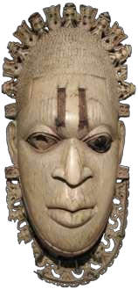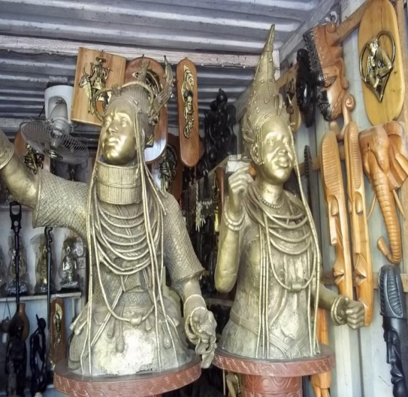

**THE SOCIO-POLITICAL ORGANIZATION OF THE BINI**

Hodgkin (1975) visited Benin in 1604 and declared: “the town seems to be very great. When you enter into it, you go into a great broad street, not paved, which seems to be seven to eight times broader than the Warmoes Street in Amsterdam….”

Bini kingdom had a unique political system, which centered on the Oba. He was the head of the kingdom and succession to the throne was by primogeniture, that is, the first surviving son succeeded his father. To Hodgkin, “the Oba was not only the civil head of state; he was also the religious head as well. He was in fact regarded as a divine person who, in himself, summed up the whole of the race… In him dwelt the divine spirit passed on to him from his forebears” (Hodgkin, 1975).

The Bini society was classified into two distinct classes:

**1.** The nobility [Adesotu]

**2.** The commoner [Ighiotu]

The nobility (Adesotu) was organized into three [03] groups of title holders:

**i.** Uzama

**ii.** Eghaevbo n’ Ogbe [palace chiefs]

**iii.** Eghaevbo n’ ore [town chiefs]

The ordinary people too, most especially those within the city, were organized into a number of guilds. The guilds were professional groups of the common people. There were a number of them such as those of the carvers, brass-workers, blacksmiths, doctors, butchers, etc. These guilds, most especially those that lived in defined quarters in the kingdom, had a system of administration which was the same as that of the villages.